Zepto E-Commerce Data Analysis using SQL

- Count the total number of rows in the dataset
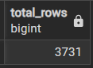

- Find all the unique product categories available in the dataset
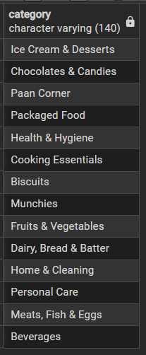

- Compare the number of products that are in stock and out of stoc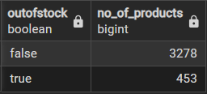

- Identify products that appear multiple times in the dataset

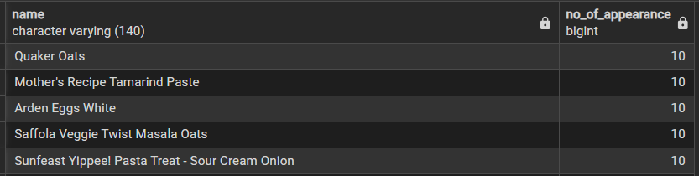

Business Insights
- Find the top 5 products offering the highest discount percentage
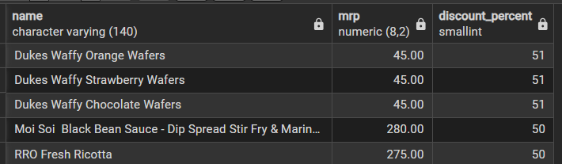

2) Identify high-priced products (MRP > ₹200) that are currently out of stock
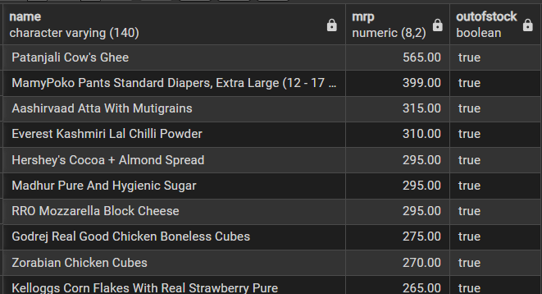

3) Calculate the estimated revenue generated by each product category
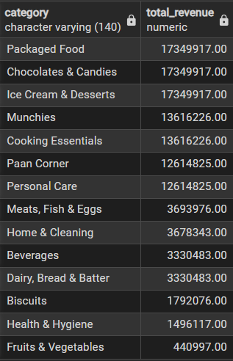

4) Find products with an MRP above ₹500 and a discount percentage below 10%
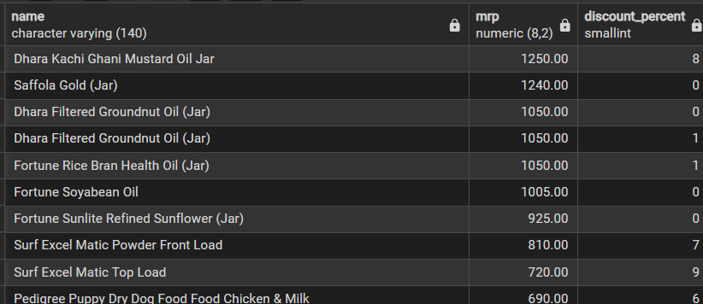

5) Identify the top 5 categories offering the highest average discount percentage

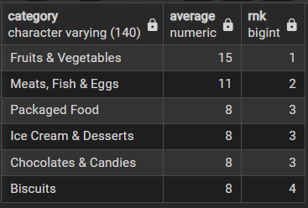

6) Calculate the price per gram for products weighing more than 500g and identify the best value products
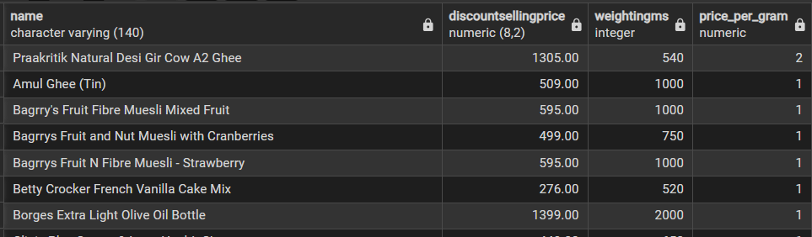

7) Classify products into Bulk, High, and Medium categories based on their weight
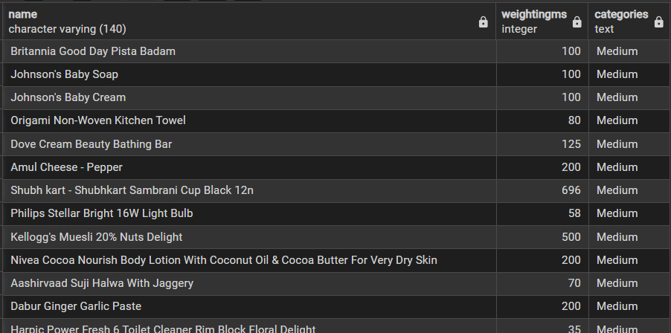

8) Calculate the total inventory weight available in each product category
